FSDI 107 – Assignment 1
Name: Charles Taggart
Theme: First React Project
GitHub Pages Link: not linked to github
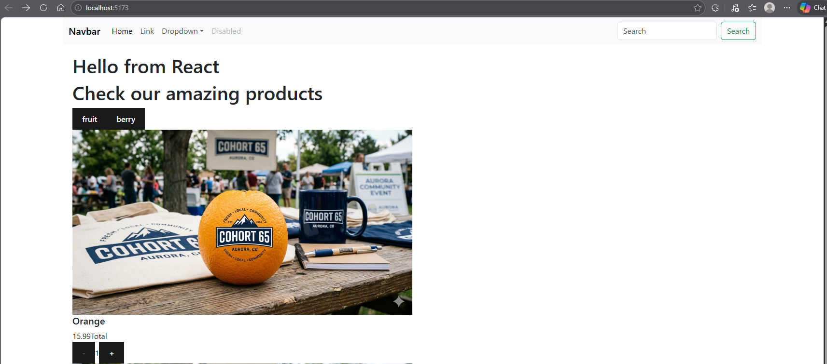
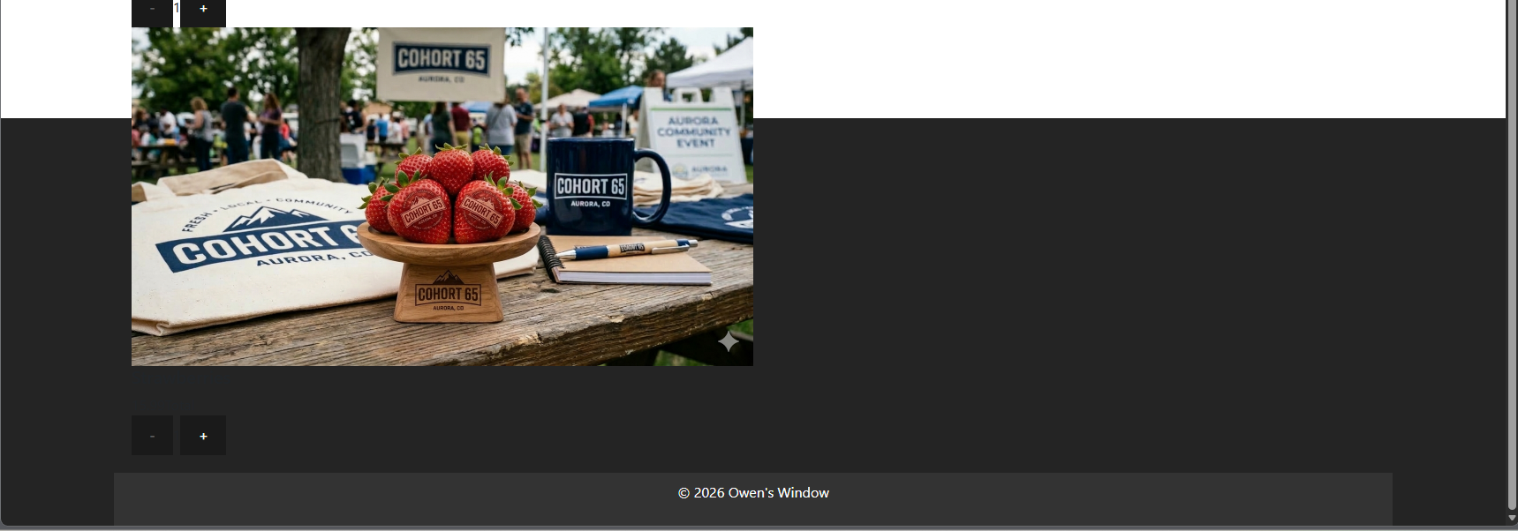
Summary of Edits:
- Added Navbar
- Added Footer
- Added Catalog page and Product component

